Experiment 1: Simple Calculator
AIM
To write a Python program to perform basic arithmetic operations using a simple calculator.
ALGORITHM
- Start the program.
- Read two numbers from the user.
- Display the arithmetic operation choices.
- Read the user's choice.
- Perform the selected operation using conditional statements.
- Display the result.
- Stop the program.
CODE
a = float(input("Enter first number: "))
b = float(input("Enter second number: "))
print("1. Addition")
print("2. Subtraction")
print("3. Multiplication")
print("4. Division")
choice = int(input("Enter your choice: "))
if choice == 1:
print("Result =", a + b)
elif choice == 2:
print("Result =", a - b)
elif choice == 3:
print("Result =", a * b)
elif choice == 4:
if b != 0:
print("Result =", a / b)
else:
print("Division by zero is not possible")
else:
print("Invalid choice")
OUTPUT
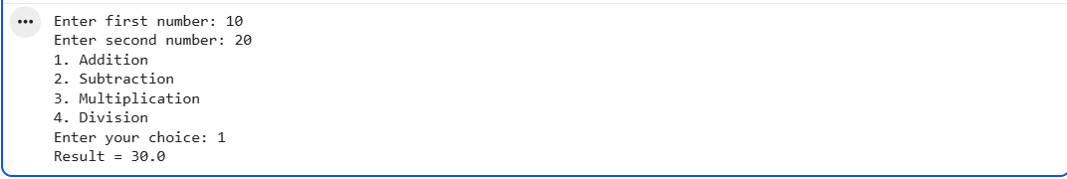
RESULT
Thus, the Python program to implement a simple calculator was executed successfully.
Experiment 2: Add Two Matrices
AIM
To write a Python program to add two matrices.
ALGORITHM
- Start the program.
- Initialize two matrices of the same size.
- Create an empty result matrix.
- Add the corresponding elements of both matrices using nested loops.
- Store the sums in the result matrix.
- Display the resultant matrix.
- Stop the program.
CODE
A = [[1, 2], [3, 4]]
B = [[5, 6], [7, 8]]
result = [[0, 0], [0, 0]]
for i in range(2):
for j in range(2):
result[i][j] = A[i][j] + B[i][j]
print("Sum of two matrices:")
for row in result:
print(row)
OUTPUT
RESULT
Thus, the Python program to add two matrices was executed successfully.
Experiment 3: Transpose a Matrix
AIM
To write a Python program to find the transpose of a matrix.
ALGORITHM
- Start the program.
- Initialize a matrix.
- Create an empty transpose matrix.
- Use nested loops to interchange the rows and columns.
- Store the elements in the transpose matrix.
- Display the transpose matrix.
- Stop the program.
CODE
A = [[1, 2, 3], [4, 5, 6]]
transpose = []
for j in range(len(A[0])):
row = []
for i in range(len(A)):
row.append(A[i][j])
transpose.append(row)
print("Transpose Matrix:")
for row in transpose:
print(row)
OUTPUT
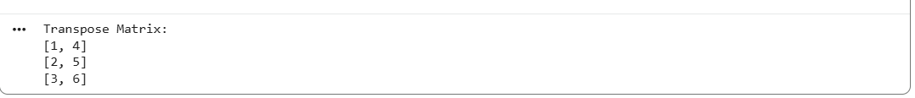
RESULT
Thus, the Python program to find the transpose of a matrix was executed successfully.

Experiment 4: Sort a Sentence in Alphabetical Order
AIM
To write a Python program to sort the words in a sentence in alphabetical order.
ALGORITHM
- Start the program.
- Read a sentence from the user.
- Split the sentence into individual words.
- Sort the words alphabetically.
- Display the sorted words.
- Stop the program.
CODE
sentence = input("Enter a sentence: ")
words = sentence.split()
words.sort(key=str.lower)
print("Words in alphabetical order:")
for word in words:
print(word)
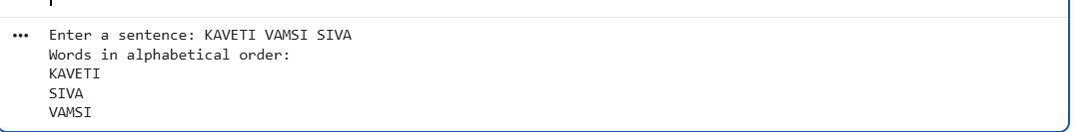
OUTPUT
RESULT
Thus, the Python program to sort a sentence in alphabetical order was executed successfully.
Experiment 5: Implement List Operations
AIM
To write a Python program to demonstrate list operations such as nested lists, length, concatenation, membership, iteration, indexing and slicing.
ALGORITHM
- Start the program.
- Create a list and a nested list.
- Find the length of the list.
- Perform concatenation with another list.
- Check membership using the in operator.
- Iterate through the list using a loop.
- Access elements using indexing and slicing.
- Display the results.
- Stop the program.
CODE
numbers = [10, 20, 30, 40, 50]
nested = [1, 2, [3, 4]]
print("List:", numbers)
print("Nested List:", nested)
print("Length:", len(numbers))
print("Concatenation:", numbers + [60, 70])
print("20 in list:", 20 in numbers)
print("100 in list:", 100 in numbers)
print("Iteration:")
for item in numbers:
print(item)
print("Indexing:", numbers[2])
print("Slicing:", numbers[1:4])

OUTPUT

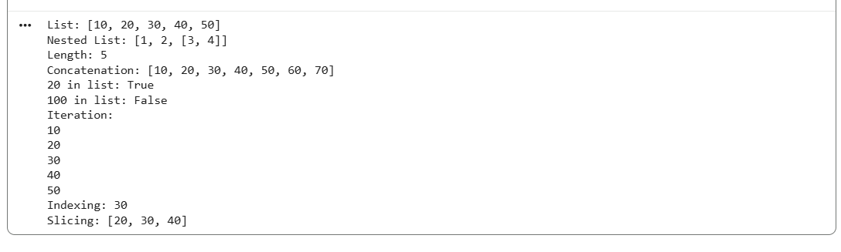
RESULT
Thus, the Python program to implement list operations was executed successfully.

